

**Project Increment 4**

**Spring 2017**

Team 14:

# The Invincibles

* GOPALA KRISHNA AVINASH TUMMALAPALLI
* SIRISHA MANTHRAMURTHY
* SAI KARTHIKEYA ADDAGADA
* SAI TEJASWEE REDDY PASHAM

# 1. Introduction

## One Stop for all media

People end up using many applications, each for a specific kind of media. This is quite burdensome and frustrating sometimes. So here comes Medianizer, where a plethora of media is brought onto a single platform, so that the customers are likely to fetch desired media in the blink of an eye. Medianizer is a universal application, where you can avail a wide range of access over media. This is a collection of media such as Music, Videos, Photos and Books where users can rent or purchase media.

# 2. Project Goal and Objectives (revised)

**2.1 Main Goal:**

The main goal of this application is to provide access to all the media like Music, Videos, Photos and Books over a single platform where people can buy or rent the desired media.

## 2.2 Objectives

2.2.1. To create a unique platform where the users can get all types of media.

2.2.2. To enable search via voice.

2.2.3. To let the user purchase or rent the desired media.

## 2.3 Specific features

**2.3.1 Browse for E-Books:** This feature enables the user to search for books related to a genre or the year of its release.

**2.3.2 Browse for Movies:** This feature enables the user to search for movies related to a genre or the year of its release.

**2.3.3 Browse for Music:** This feature enables the user to search for music related to a genre or the year of its release.

**2.3.4 Purchase Media:** User can rent or buy media.

**2.3.5 Voice Search:** User can voice search for media.

## 2.4 Significance

This application is a platform that provides access to a wide range of media like Music, Videos, Photos and Books over a single platform.

# 3.Project Plan

1. **Zen- Hub Screenshot:**

For the first increment we have issues regarding creating a login page, registration page, Voice API and working on unit test cases.

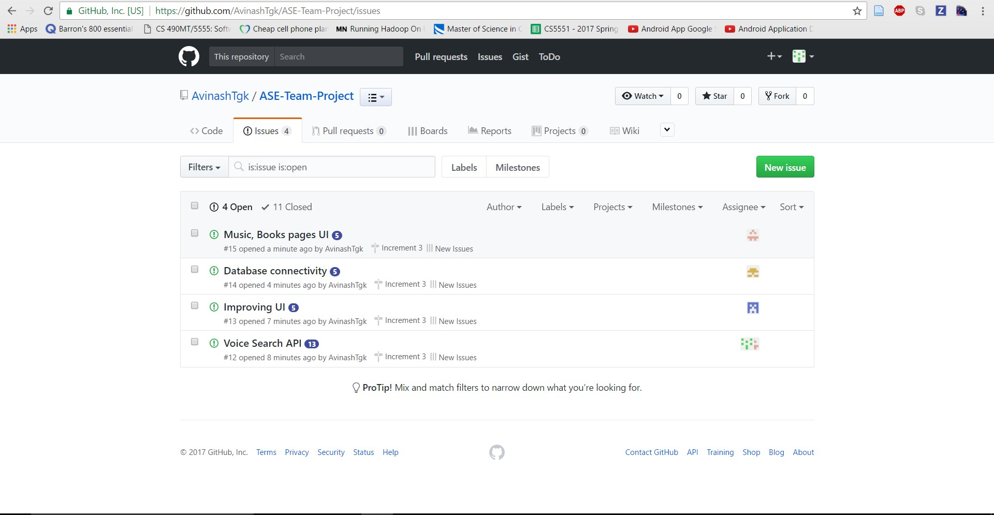

1. **Project Timeline, Members, Task Responsibility:**

Below is the screenshot describing the new issues and issues which are in progress state, done state and all other states too.

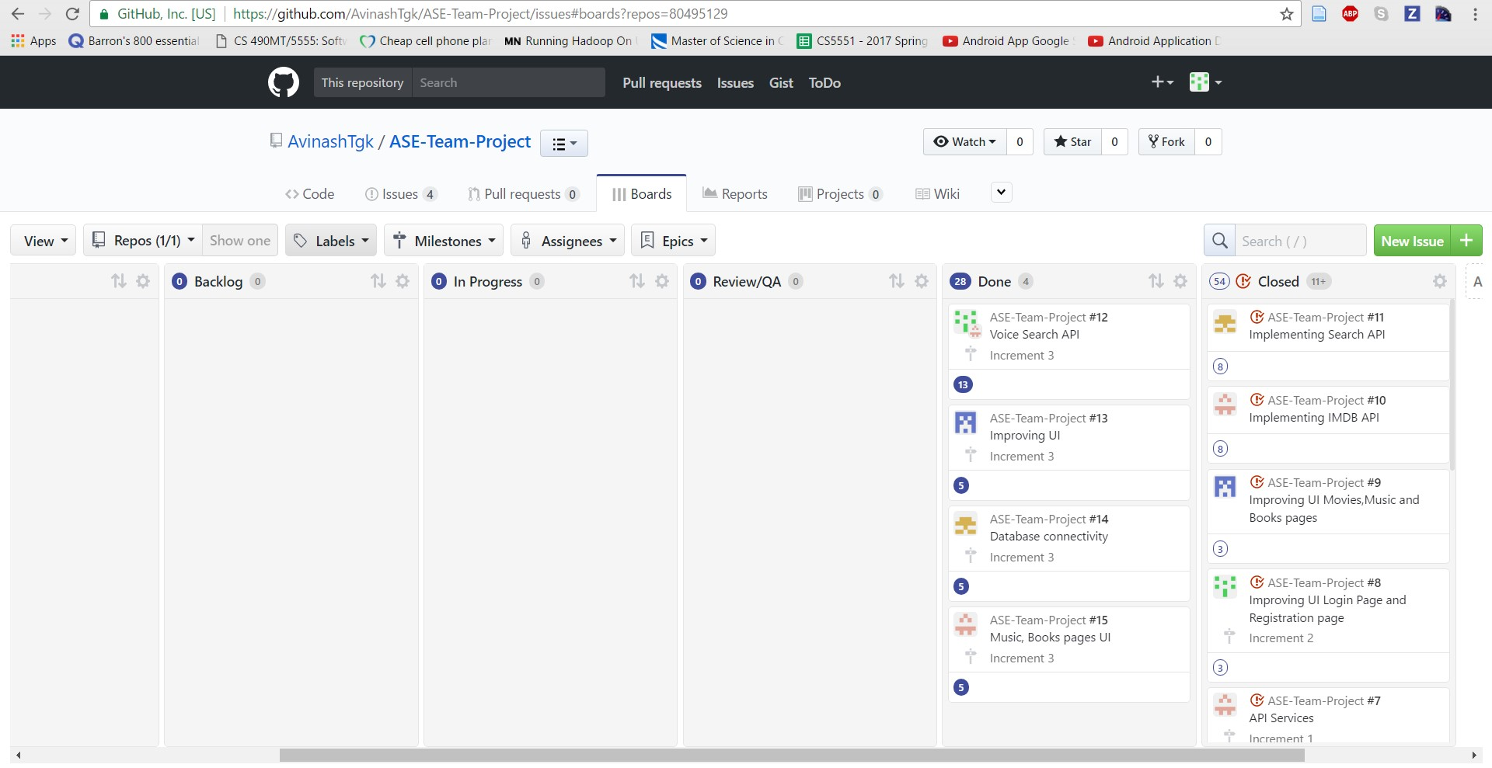

## 3. Burn-Down chart

The following is the Burndown chart:

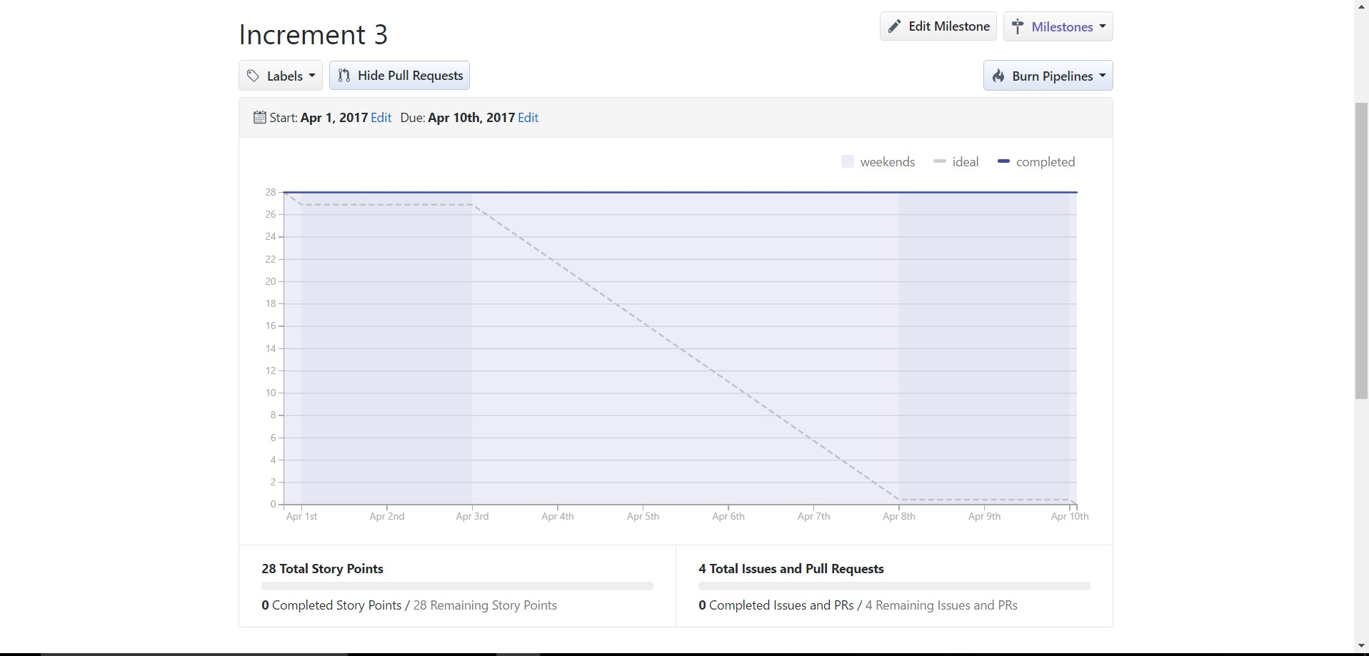

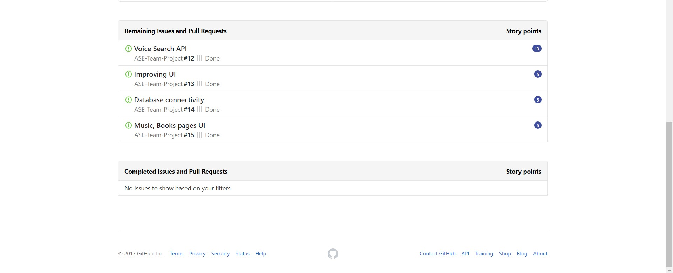

# 4. Fourth Increment Report

## 4.1 Existing Services/REST API

### 4.1.1 API’s Used

* **Search API:**

Search API is used in the application to search for the required song or book or a movie.

* **Voice Search API:**

Voice Search API is used in the application which accepts the voice search commands and renders the desired results.

* **IMDb API:**

IMDb API is used in the application to get the results for movie search by redirecting the user to its IMDb page.

* **Spotify API:**

Spotify API is used in the application to search for the desired music which redirects the user to Spotify website.

**4.2 Detail Design of Features:**

**4.2.1. Wireframes**

## Login Page

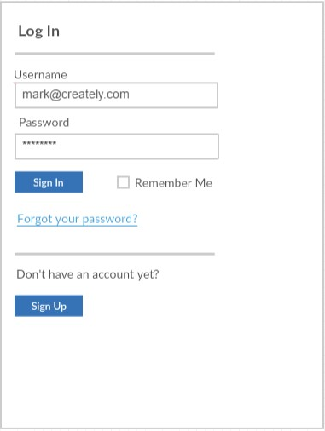

## Registration Page

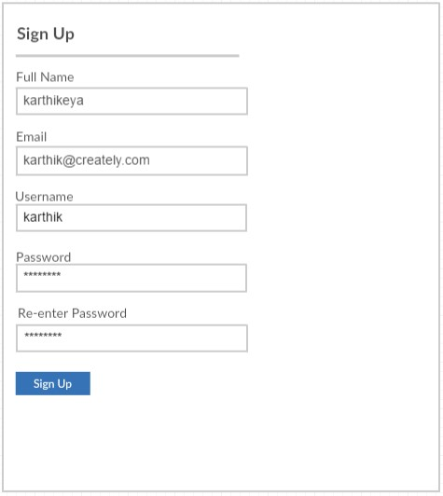

## Home Page

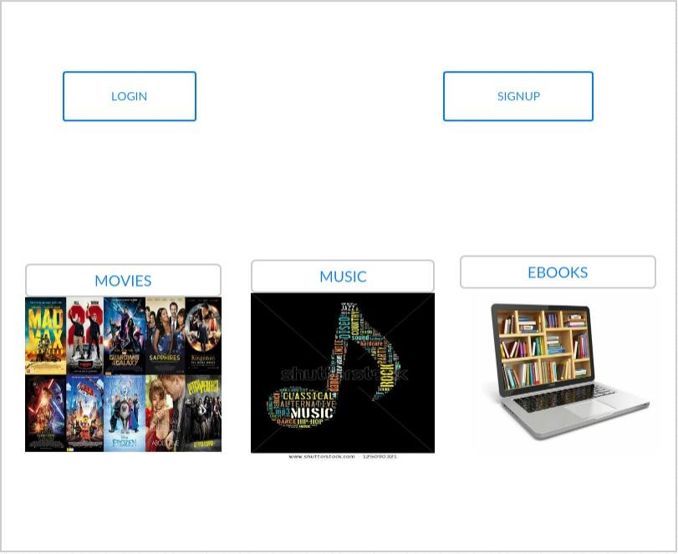

## Movie Page

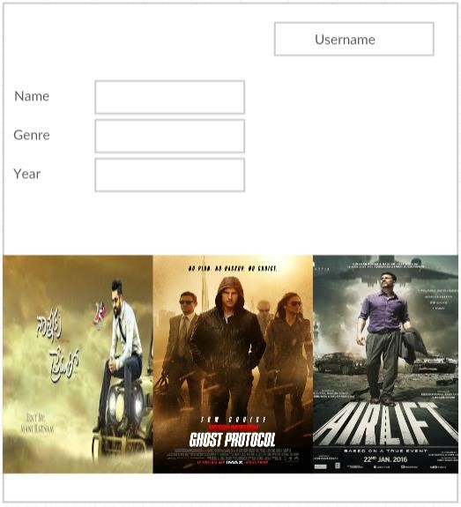

## Movie Item Page

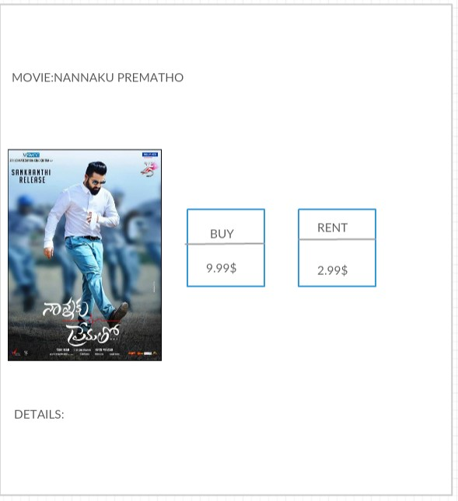

## Buy Page

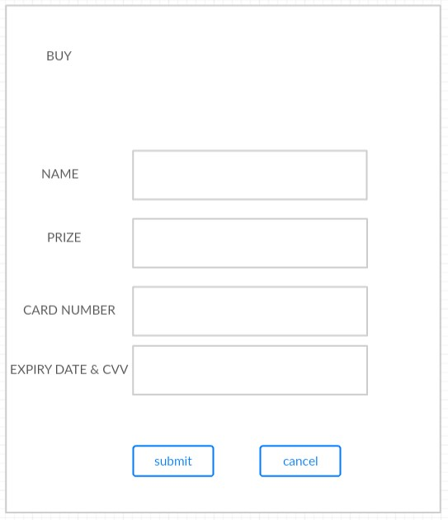

### 4.2.2 Class Diagram

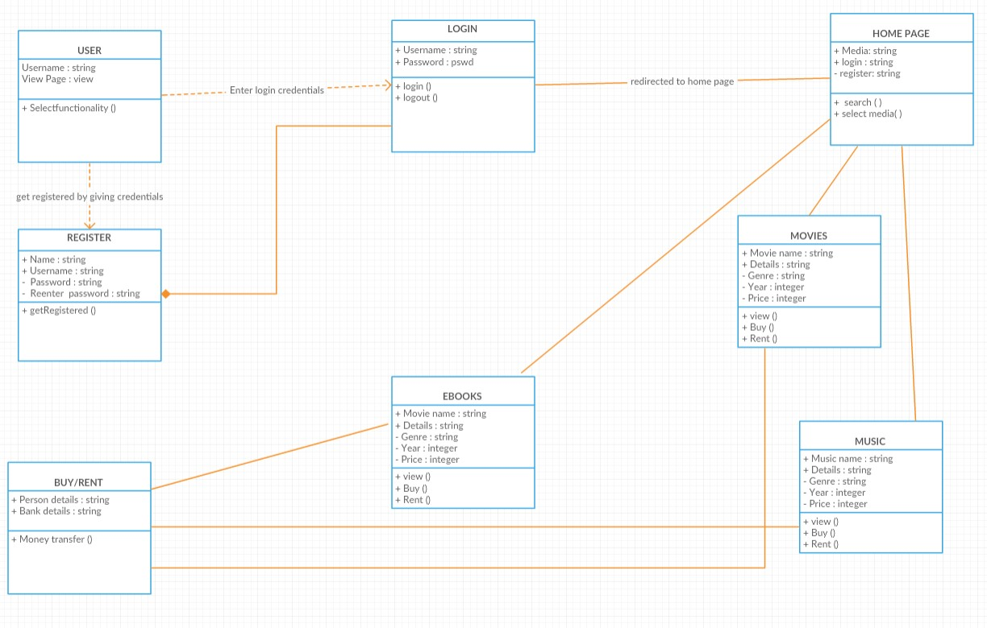

### 4.2.2 Sequence Diagram

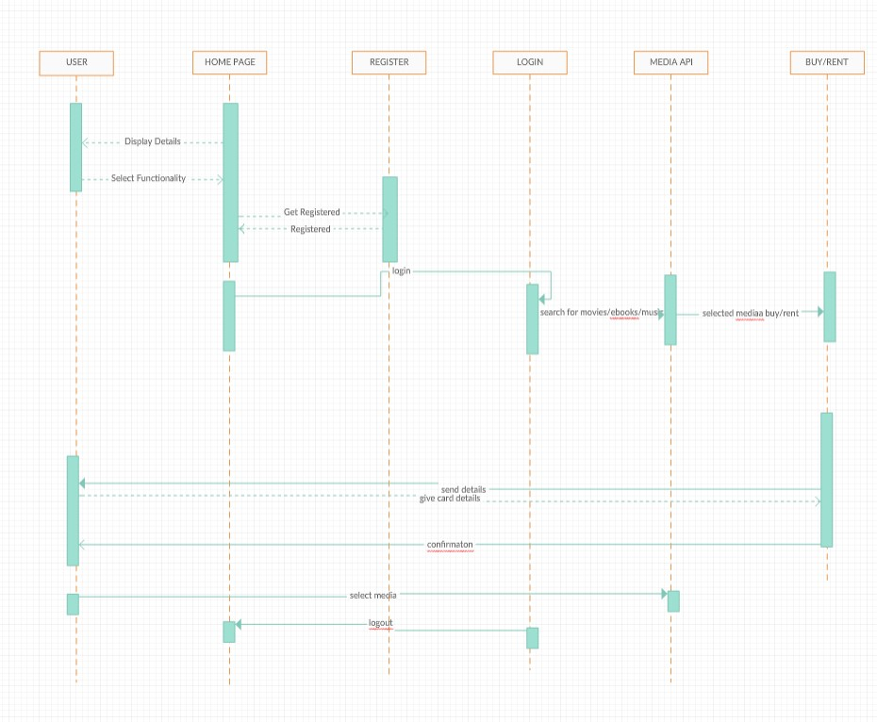

### 4.2.3 Architecture Diagram

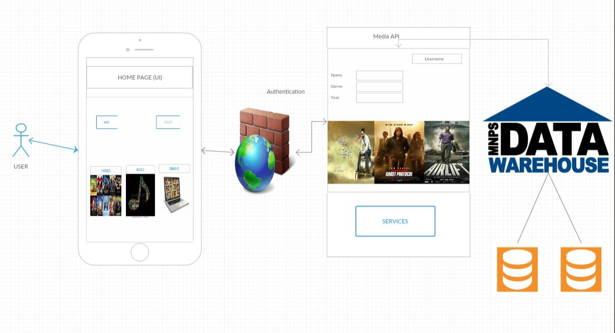

### 4.2.4 User Stories

|  |  |  |
| --- | --- | --- |
| As a user | I want to | So that |
| search for a movie | I can access movies |
| search for music media | I can access music |
| Search for e-books | I can access e-books |
| Purchase media | Buy or Rent media |
| Voice search | Get results based on voice commands |
| View short videos | I can access movie trailers |

### 4.2.5 Unit Testing

**Test Cases for Login and Signup pages:**

|  |  |  |  |
| --- | --- | --- | --- |
| **Case** | **Test case Description** | **Expected Result** | **Actual Result** |
| **Login** | Enter invalid username and password | Error message pops up saying invalid credentials. | PASS |
| **Login** | Enter invalid username and valid password | Error message pops up saying invalid credentials. | PASS |
| **Login** | Enter valid username and invalid password | Error message pops up saying invalid credentials. | PASS |
| **Login** | Enter valid username and password | Page should redirect to Home page | PASS |
| **Signup** | Email id format should end with @mail.com | Give error message incorrect email id format | PASS |
| **Signup** | Password of length 8 characters | Gives error message password is weak | PASS |
| **Signup** | Password and confirm password should match | If this succeeds it redirects to login page | PASS |
| **Search** | Enter a valid name to search for | Retrieves search results | PASS |
| **Voice Search** | Give a voice command | Retrieves search results | PASS |
| **IMDb Search** | Search for a movie | Redirects to IMDb page | PASS |
| **Spotify** | Search for music | Redirects to Spotify website | PASS |
| **Suggestions** | Type in the text box | Suggestions appear from database | PASS |

# 5. Implementation and Deployment

We have implemented the Medianizer application in Android Studio onto an emulator. Following screenshots describe the flow of the application.

**5.1** Our application, “Medianizer” in the menu.

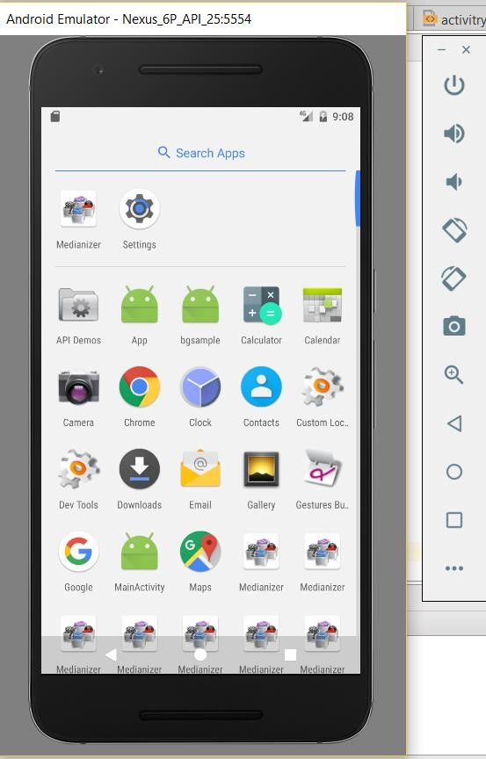

**5.2** By clicking on the application, the following login page appears.

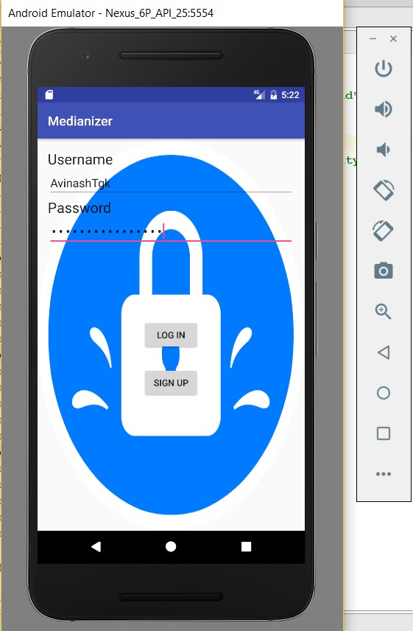

**5.3** If the user is new, on clicking signup the following form appears.

(with user details)

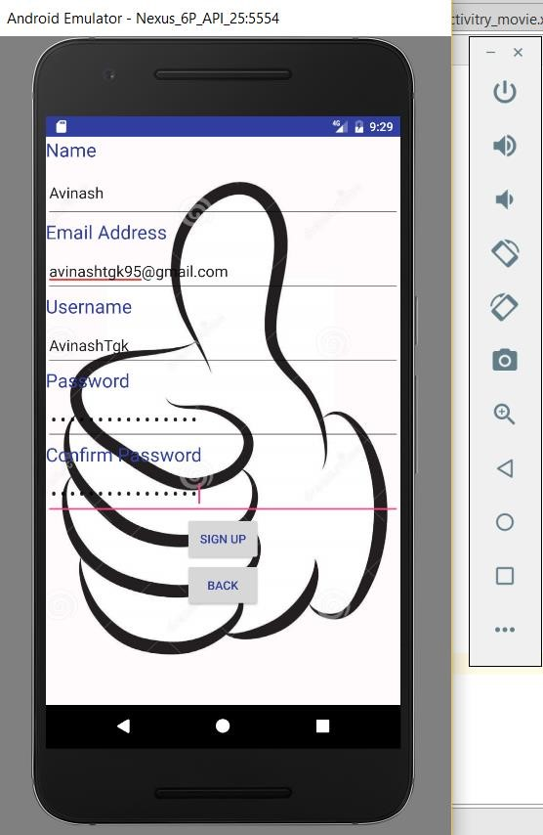

**5.4** Upon logging in, the following index page appears.

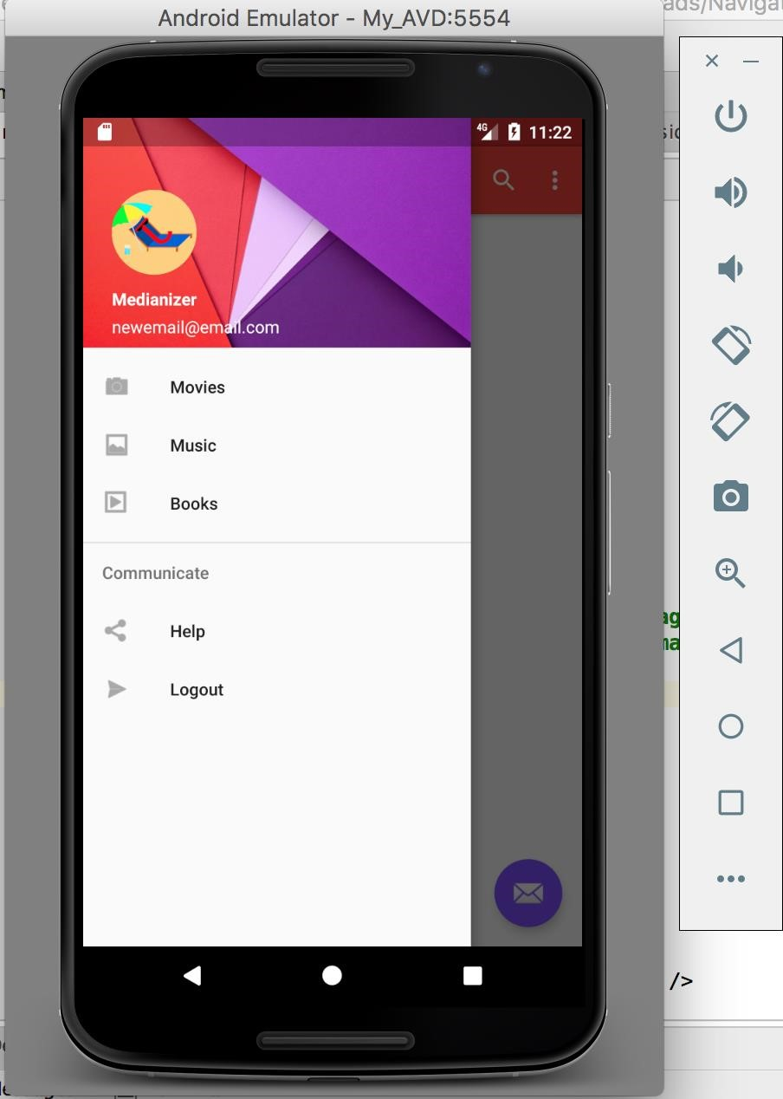

**5.5** On selecting the desired category, the respected page opens.

(similar pages for all categories)

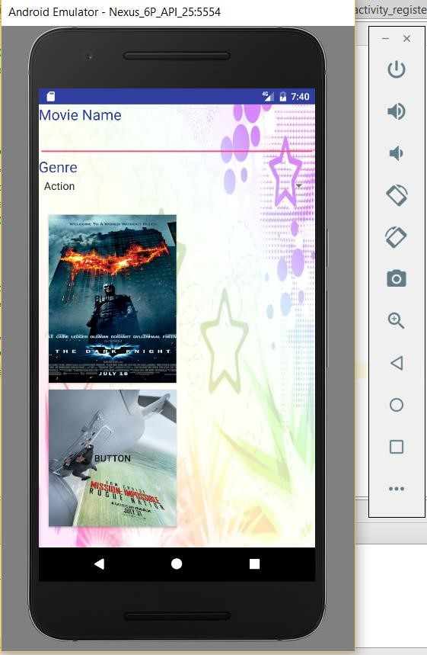

**GitHub wiki page URL**: [https://github.com/AvinashTgk/ASE-TeamProject](https://github.com/AvinashTgk/ASE-Team-Project)

# 6. Project Management

## Implementation status report

**Technologies Used:**

Android SDK, J2EE, XML.

**Work Completed:**

* Design and Architecture of the Application
* Login and Registration using Android
* Search API Implementation
* Voice search API Implementation
* IMDb API Implementation
* Spotify API Implementation
* Suggestions API Implementation
* Providing a database to the application using Firebase

**Contributors:**

* Sai Karthikeya Addagada – 25%
* Sirisha Manthramurthy – 25%
* Sai Tejaswee Reddy Pasham – 25%
* Gopala Krishna Avinash Tummalapalli – 25%

**Contribution:**

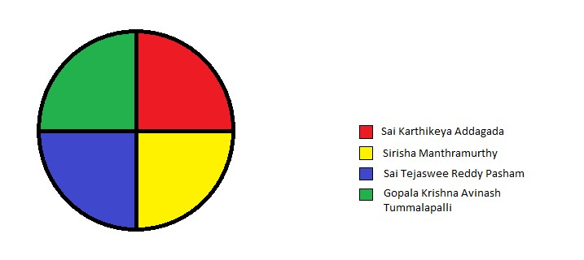

# 7. Bibliography

* [http://creately.com](http://creately.com/)
* <https://developer.android.com/studio/index.html>
* [https://console.developers.google.com/apis/dashboard?project=hale-inn158921&duration=PT1H](https://console.developers.google.com/apis/dashboard?project=hale-inn-158921&duration=PT1H)
* <http://stackoverflow.com/>
* <https://www.w3.org/standards/xml/>